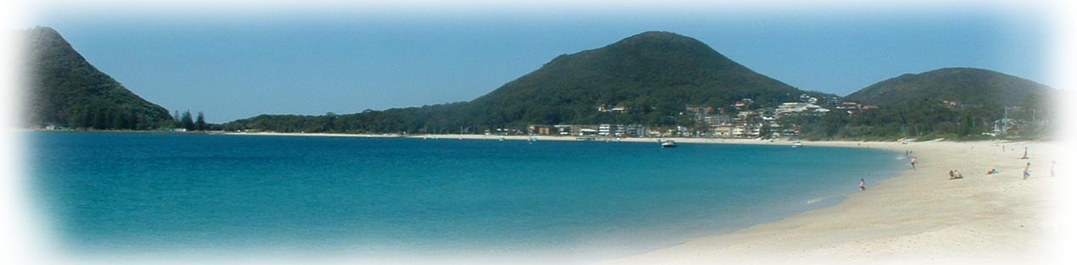
Shoal Bay Community Association Inc.

9 Lionel Avenue Shoal Bay NSW 2315 4981 0565 mob 0419 144 110 email: secretary.shoalbayca@gmail.com

Test

www.shoalbay.org.au

November 2022

Department of Communities and Justice

Re: SUBMISSION ON THE FUTURE USE TOMAREE LODGE SITE

The Shoal Bay Community Association (SBCA) was incorporated on November 26, 2010, to provide a voice for the community seeking infrastructure improvements and environmental protection for the benefit and enjoyment of Shoal Bay residents and visitors now and into the future.

Over many years SBCA has been involved in planning and lobbying the NSW State Government to ensure that this iconic site of Tomaree Headland remains in public hands and congratulates the Government in seeking consultation in deciding the future of the site.

At a recent Management Committee meeting of the SBCA it was resolved that our submission to the NSW Government look at the macro level rather getting into the miniature.

The SBCA acknowledges the continuing custodianship, knowledge, and connection of the traditional owners of the land, the Worimi people.

Essentially the SBCA submission calls for:

- That the NSW Government (NSWG), through the Department of Communities and Justice, enter negotiations with Port Stephens Council (PSC) to enable the Council to become the “Land Manager” of the site.

This would be subject to reaching an agreement with the Government that the recurrent expenditure incurred to maintain the site continue being met by the NSWG for a period of say 5 years.

- A comprehensive Plan of Management (POM) be undertaken of the site.

A POM process would ensure that all community consultation be fully transparent and provide the opportunity for any individual or organization to submit a proposal which would be professionally assessed by an independent consultant undertaking the POM.

- The establishment of a Community Trust to take over the management of the site which would have to be financially independent to meet the eventual full costs of managing and maintaining the site with the purpose of implementing the POM.

A suggested Trust membership would include a representative from each of the following the The Worimi Aboriginal Land Council; NSW National Parks; PSC; two community representatives and an executive officer.

Yours sincerely

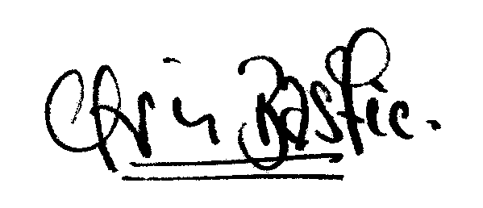
Chris Bastic
0418 771 552
Chris.bastic@gmail.com

