TRRA assessment of DA 2016-557-2 for 9 Shoal Bay Road, Shoal Bay.
DRAFT 14/3/22
On exhibition until 5pm Friday 18 March - See http://datracker.portstephens.nsw.gov.au/Application/ApplicationDetails/016-2016-00000557-002/
The DA is for ‘S4.55(1A) Modification to approved motel accommodation comprising a four storey building comprising with 16 units – external design changes, amendment to basement and parking areas, internal reconfiguration of units and a rooftop terrace’
The application is by Hugh Jones of Park and Shop Pty Ltd. Mr Jones is also shown as the planner preparing the Statement of Environmental Effect (SoEE) for the Le Mottee Group Pty Ltd. While some or all of the applicant, owner and payer details have been redacted from the pre-lodgement application form, the Streetscape Analysis by Terras shows Ryan Palmer - Palmer Holdings Pty Ltd as the client. The pre-lodgement application form shows the Council affiliations of Palmer (Mayor), Le Mottee (former Councillor) and Jones (former employee).
Mayor Palmer is as entitled as any other property owner to seek development consent. He would however have to declare a conflict of interest and stand aside from any Council discussion or decision on the DA.
We are advised that the DA has been ‘called up’ for determination by Council, so it will not be decided by staff under delegated authority.
The proposed changes
The extent of the proposed changes is not mentioned until pp5-6 of the SoEE:
‘The proposed Motel Accommodation will consist of nine (9) units made up of two and three-bedroom units and communal spaces. Each unit shall provide short-term accommodation to visitors on a commercial basis. …

The proposed modification includes an updated external appearance…..’ (p6)
The SoEE asserts that:
‘The proposal does not represent a major departure to the approved development.’ (p2)
This is presumably the basis of the application being made under s.4.55(1A) of the EPA Act – ‘minimal environmental impact’ and not under s.4.55(22) – ‘other modifications’. We are advised that ‘the application is being assessed externally by a planning consultant. They will determine in their assessment whether the application falls with the s4.55(1A) category or not’
The most obvious changes are a reduction in the number of accommodation units from 16 (14 studio and 2x 2 bedroom) to 9 (6x 2 bedroom and 3x 3 bedroom apartments). The other major change is the replacement of the approved hip roof with a flat roof terrace, with ‘architectural features’ – a pergola and screening – which rise more than a metre above the approved height of the hip roof ridge. It is not clear if there would be a roof on the pergola (solid, louvre, shade sail?).
The estimated cost of the development has inexplicably increased from $2.5 million in 2016 to $6.7 million in 2022, despite the changes being described as minor.
TRRA’s assessment is that the proposed changes are in some respects positives (qualified) but in others negative, or at least raising outstanding questions which should be resolved before any decision.
Potentially positive changes (with qualifications)
- An improved visual appearance, replacing the unimaginative design of the approved building (though this will always be a subjective judgement) – see images below from the supporting documentation.

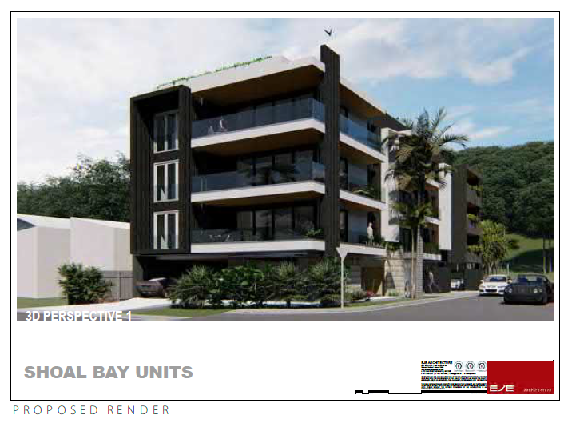  2022 proposed design 3D perspective from NNW | 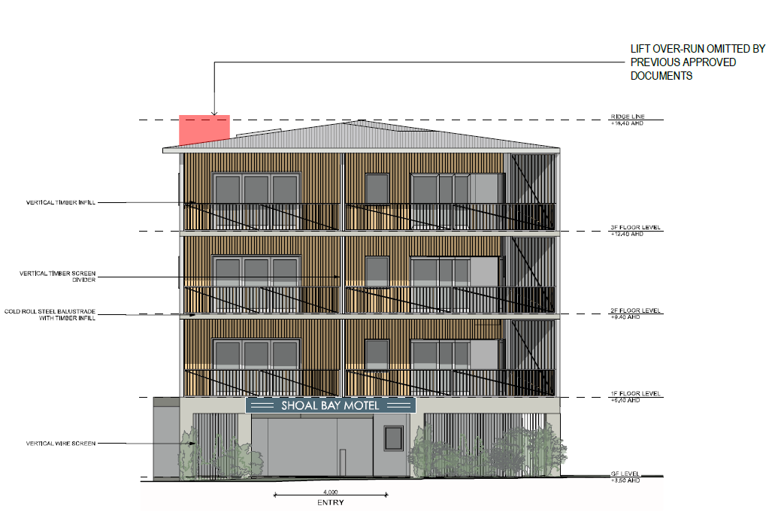  2016 approved design – north elevation

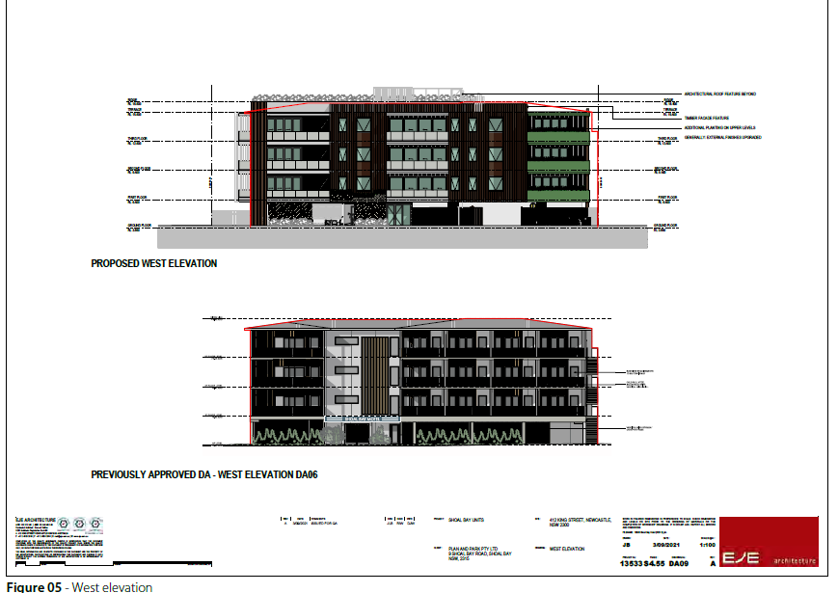
- A better contribution to housing supply, with larger units potentially more attractive to permanent residents – reinforced by the provision of individual laundries in each unit. However, permanent occupancy is seemingly ruled out by the assertion that ‘Each unit shall provide short-term accommodation to visitors on a commercial basis’. It is unclear whether there is a specific definition of ‘motel’ or if there will be anything to prevent permanent occupancy of one or more of units.
Potentially negative changes, or those requiring further consideration
- The additional height to the top of all structures on the roof, which is not quantified in any of the documents. We are advised by Council staff that ‘From review of the plans it appears that the maximum additional height proposed as a result of the architectural roof feature is 2.2m. There appears to be a discrepancy with the scale of the plans.’

- The new design therefore exceeds the approved height by 17%, and the LEP height limit for the site by 66%. Given that the 2016 approval already granted a 42% excess over the 9 metre height limit for the site, it is difficult to see why the applicant feels justified in seeking another significant variation.

- The extra height will be very visible from the foreshore, Shoal Bay jetty and out in the Bay, accentuating the significant difference from the 4 buildings to the east – 3x2 storey and 1x3 storey but all a similar height of between 5 & 7 metres – the three closest being less than half the height of the proposed ‘motel’.
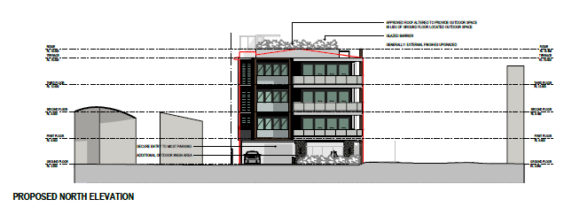

We are advised that ‘The development was presented to the Urban Design Panel prior to lodgement and has been re-referred as a part of the assessment of this application’. The opinions of the Panel, while not binding, are taken into account in the assessment of the DA, and are usually at least summarised in the assessment report.

- Only 8 car parking spaces are proposed for the 9 units + 1 accessible space and 1` visitor space. This seems completely inadequate for 2 and 3 bedroom units, whether they are occupied by short term holiday makers or by permanent residents. If the building is to be a ‘motel’ as claimed, then at least one space should be required for staff. Extra vehicles and trailers associated with the accommodation will inevitably have to be parked on the surrounding streets, some of which are scheduled to have ‘paid parking’ introduced soon. Normal parking standards for the proposed development would require at least 12 spaces.

- If the development is approved as a ‘motel’ it will qualify for a 50% discount on the Infrastructure contributions payable to Council (Local Infrastructure Contributions Plan, 2.6.3 Tourist and Visitor Accommodation). Given that the new design seems to foreshadow permanent occupancy, then unless approval could be conditioned to prevent this, Council could be foregoing a significant contribution to revenue.
Images from Annex B – Streetscape Analysis and/or Annex C - Visual Impact Assessment
planning@trra.com.au

